 | 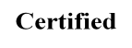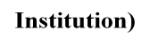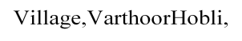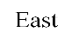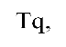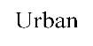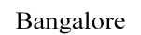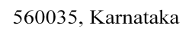
DEPARTMENT OF COMPUTER SCIENCE ENGINEERING (BCS701) INTERNET OF THINGS
LAB MANUAL
SEMESTER –VII-( 2025–26 )

PREPARED BY:

Mrs.Manjupriya S, ASSISTANT PROFESSOR




BANGALORE TECHNOLOGICAL INSTITUTE

(An ISO 9001:2015 Certified Institution)
Kodathi Village,VarthoorHobli, Bangalore East Tq, Bangalore

Urban District, Bangalore-560035, Karnataka

TABLE OF CONTENTS

Sl. No. | PARTICULARS
1 | Develop a program to blink 5 LEDs back and forth.
2 | Develop a program to interface a relay with Arduino board
3 | Develop a program to deploy an intrusion detection system using Ultrasonic and sound sensors.
4 | Develop a program to control a DC motor with Arduino board.
5 | Develop a program to deploy smart street light system using LDR sensor.
6 | Develop a program to classify dry and wet waste with the Moisture sensor (DHT22)
7 | Develop a program to read the pH value of a various substances like milk, lime and water.
8  4 | Develop a program to detect the gas leakage in the surrounding environment.
9 | Develop a program to demonstrate weather station readings using Arduino.
10 | Develop a program to setup a UART protocol and pass a string through the protocol.
11 | Develop a water level depth detection system using  Ultrasonic sensor.
12 | Develop a program to simulate interfacing with the keypad  module to record the keystrokes

Step-by-Step: Tinkercad Arduino Installation and Setup

Step 1: Open Tinkercad Website
- Go to https://www.tinkercad.com in your browser.
Step 2: Create an Account
- Click Join Now or Sign Up.
- Fill out your details or sign in using Google/Microsoft accounts.
- Verify your email if required.
Step 3: Log in to Your Tinkercad Account
- Enter your credentials and log in.

Step 4: Navigate to Circuits
- Click the Circuits option on the left sidebar.

Step 5: Create a New Circuit
- Click on Create new Circuit button.

Step 6: Add an Arduino Board
- In the components panel on the right, search for Arduino Uno.
- Drag and drop it into the workspace.

Step 7: Add Components
- Drag other components like LEDs, resistors, sensors, buttons as needed.

Step 8: Write Code
- Click the Code button to open the code editor.
- You can use block-based or text-based Arduino code.

Step 9: Simulate Your Circuit
- Click Start Simulation to run your circuit and check functionality.

Step 10: Save Your Work
- Use the Save button to save your circuit project.

Tips:
- Always test your circuits in simulation before physical implementation.
- Use the Tinkercad learning tutorials for more help.
- Experiment with simple circuits first to get comfortable.

Program 1:
Develop a program to blink 5 LEDs back and forth.
Aim:
To develop an Arduino program that makes 5 LEDs blink sequentially back and forth, creating a back-and-forth running light effect.
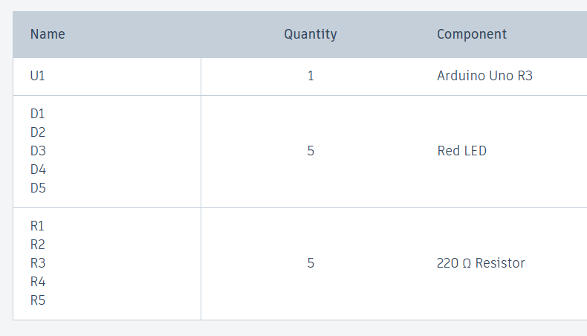
Component:
Circuit:
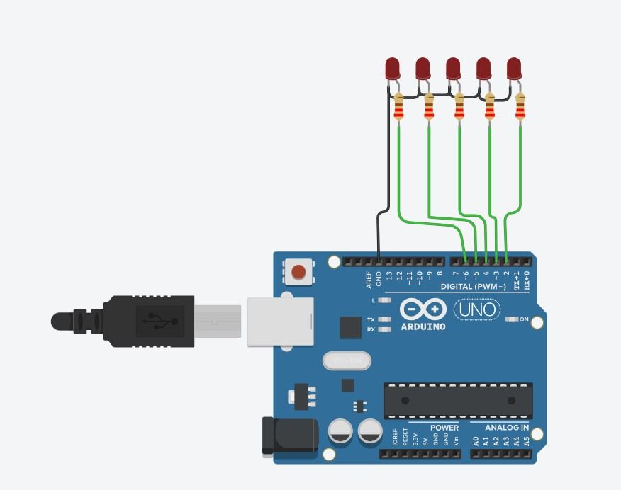

Procedure:
Step 1: Open Tinkercad
- Go to https://www.tinkercad.com
- Click “Circuits” → “Create new Circuit”

Step 2: Add Components
  - Drag and drop:
    - 1 Arduino Uno
    - 5 LEDs
    - 5 Resistors
    - (Optional) 1 Breadboard Step 3: Wiring the LEDs
For each LED:
  - Anode (long leg) → connect to a digital pin via a resistor (220 Ω):
    - LED1 → Pin 2
    - LED2 → Pin 3
    - LED3 → Pin 4
    - LED4 → Pin 5
    - LED5 → Pin 6
  - Cathode (short leg) → connect to GND Step 4: Add the Arduino Code
Click “Code” → change from Blocks to Text. Delete the default code and write the following:

Program Code:
int ledPins[] = {2, 3, 4, 5, 6}; int numLeds = 5;
int delayTime = 150;

void setup() {
for (int i = 0; i < numLeds; i++) { pinMode(ledPins[i], OUTPUT);
}
}

void loop() {
for (int i = 0; i < numLeds; i++) { turnOnOnly(i); delay(delayTime);
}

for (int i = numLeds - 2; i > 0; i--) { turnOnOnly(i);
delay(delayTime);
}
}
void turnOnOnly(int idx) {
for (int j = 0; j < numLeds; j++) { digitalWrite(ledPins[j], (j == idx));
}
}
Step 5: Start Simulation
  - Click “Start Simulation”
  - LEDs will blink from left to right, then right to left, continuously

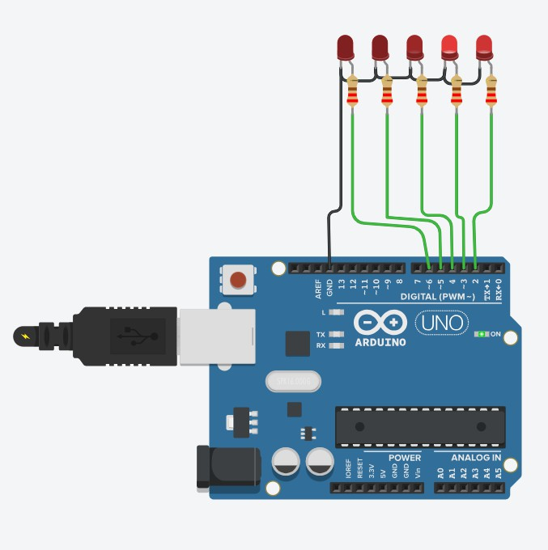
Output:

Program 2:
Develop a program to interface a relay with Arduino board.
Aim
To interface a relay module with an Arduino board to control high voltage devices using Arduino’s digital output pin.
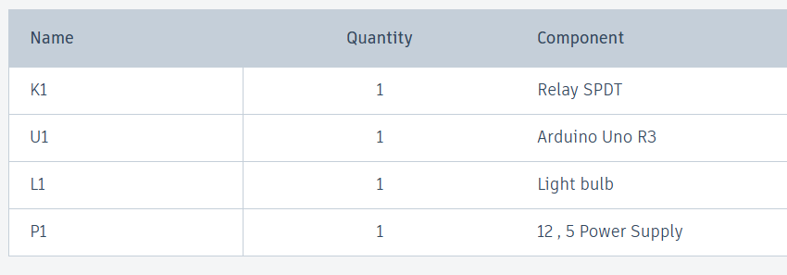
Components:

Circuits:
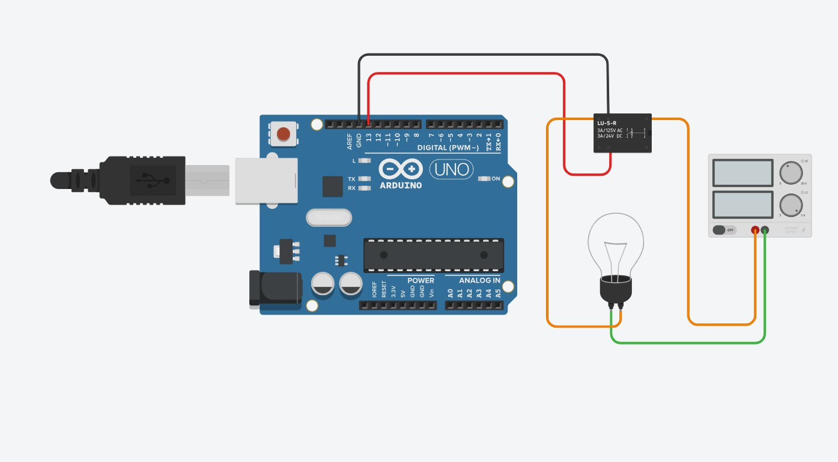

PROCEDURE:
Step 1: Open Tinkercad
- Go to: https://www.tinkercad.com/
- Log in or create a free account.
- Click on “Circuits” from the left menu.
- Click “Create New Circuit”.

Step 2: Add Components
Drag and drop the following components into your workspace:
  - Arduino Uno R3
  - Relay Module (5V)
  - Light Bulb
  - DC Power Supply (to simulate AC power)
  - Jumper wires

Step 3: Wiring the Components
Follow this wiring diagram (as shown in the image):
➤ Arduino to Relay:
  - Digital Pin 7 → IN pin of the Relay module
  - 5V → VCC on Relay
  - GND → GND on Relay
➤ Relay to Light Bulb & Power Supply:
  - Power supply positive (+) → COM on Relay
  - NO (Normally Open) on Relay → One terminal of the bulb
  - Other terminal of the bulb → Power supply negative (-)

Step 4: Add the Code
Click the “Code” button and use Text (C++) mode.

Program Code:
// C++ code
//
void setup()
{
pinMode(13, OUTPUT);
}

void loop()
{
digitalWrite(13, HIGH);
delay(1000); // Wait for 1000 millisecond(s) digitalWrite(13, LOW);
delay(1000); // Wait for 1000 millisecond(s)
}
Step 5: Start Simulation
- Click “Start Simulation”.
- The relay should click every 2 seconds, toggling the bulb ON and OFF.

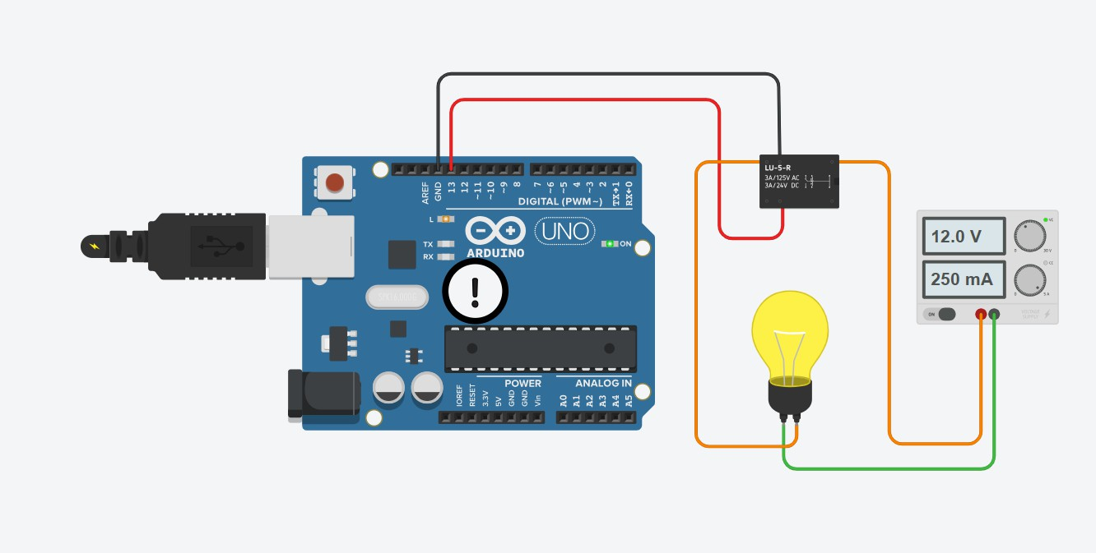
Output:

Program 3:
Develop a program to deploy an intrusion detection system using Ultrasonic and sound sensors.
Aim
To develop an intrusion detection system using an ultrasonic sensor to detect movement within a certain distance and a sound sensor to detect noise, triggering an alarm or indicator when an intrusion is detected.
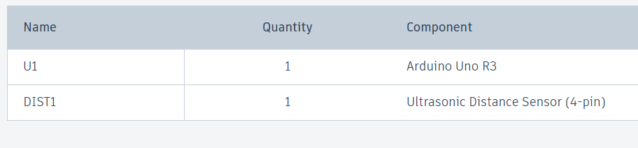
Components:

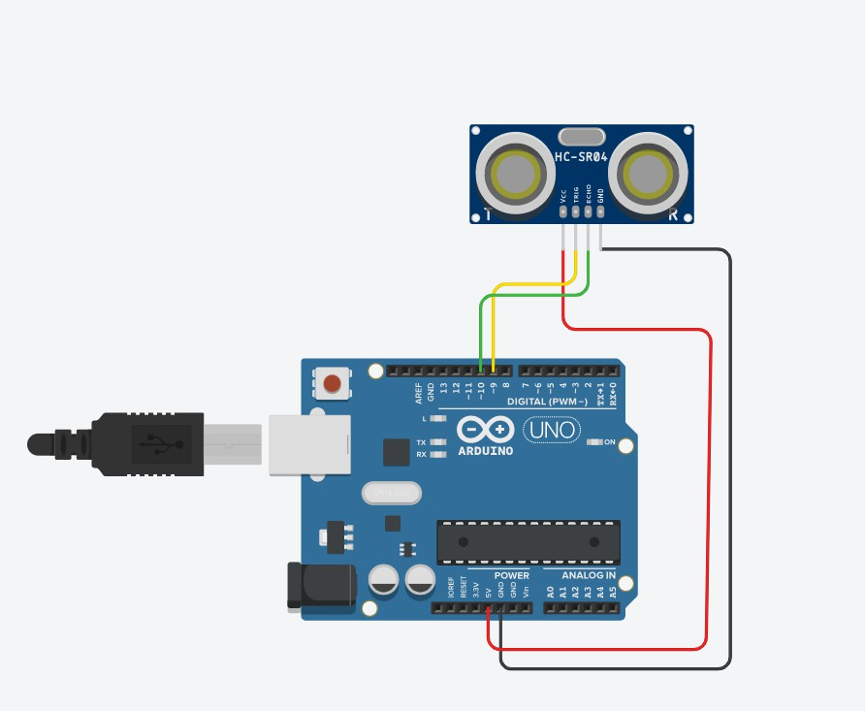
Circuit:

PROCEDURE:
- Open Tinkercad:
  - Go to https://www.tinkercad.com
  - Log in or create a free account.

- Create a New Circuit:
  - Click on “Circuits” from the left-hand menu.
  - Click “Create New Circuit.”

- Add Components:
Drag and drop the following components into your workspace:
  - 1x Arduino Uno R3
  - 1x Ultrasonic Sensor HC-SR04
  - (Optional: 1x Breadboard if needed for future expansion)
- Connect the Ultrasonic Sensor:
Referencing your image, do the wiring as follows:

HC-SR04 Pin | Connects To
VCC | Arduino 5V
GND | Arduino GND
Trig | Arduino Digital Pin 9
Echo | Arduino Digital Pin 10

Use wires to make these connections. Match the colors as per your preference. The image uses:
  - Red for VCC
  - Black for GND
  - Green for Echo
  - Yellow for Trig

- Add the Code:
Click the "Code" button (top-right), select "Text" mode, then paste the following Arduino code:

Program code:
// Pin definitions #define trigPin 9
#define echoPin 10 #define soundSensor A0
#define alertPin 13 // LED or buzzer

void setup() { Serial.begin(9600); pinMode(trigPin, OUTPUT); pinMode(echoPin, INPUT); pinMode(alertPin, OUTPUT);
}

void loop() {
// --- Ultrasonic Sensor Logic ---digitalWrite(trigPin, LOW); delayMicroseconds(2);

digitalWrite(trigPin, HIGH); delayMicroseconds(10); digitalWrite(trigPin, LOW);

long duration = pulseIn(echoPin, HIGH); int distance = duration * 0.034 / 2;

// --- Sound Sensor Logic ---
int soundLevel = analogRead(soundSensor);

// --- Serial Output ---Serial.print("Distance: "); Serial.print(distance); Serial.print(" cm | Sound: "); Serial.println(soundLevel);

// --- Alert Condition ---
if ((distance > 0 && distance < 50) || soundLevel > 600) { digitalWrite(alertPin, HIGH); // Alert: Intruder detected
} else {
digitalWrite(alertPin, LOW); // No intrusion
}

delay(300);
}

- Start Simulation:
  - Click “Start Simulation.”
  - Open the Serial Monitor (click the small monitor icon or click the dropdown beside "Start Simulation").
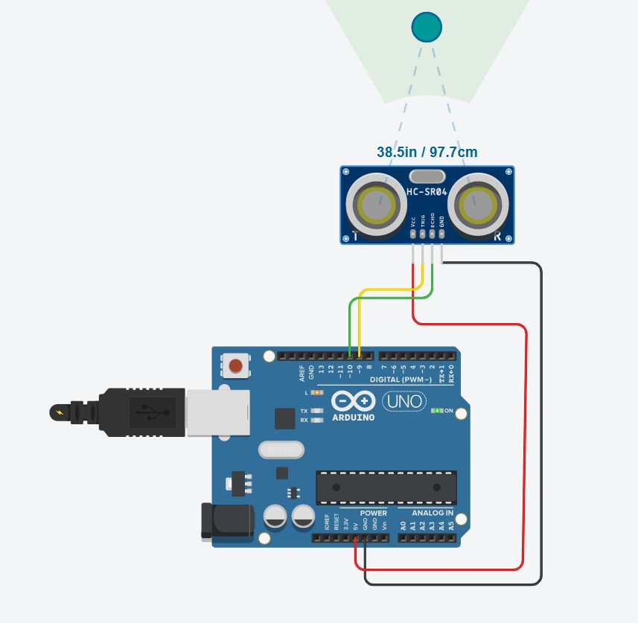
  - You should see the distance readings in centimeters. Output:

Serial Monitor:
Distance: 96 cm | Sound: 387
Distance: 96 cm | Sound: 685
Distance: 96 cm | Sound: 101
Distance: 114 cm | Sound: 88
Distance: 125 cm | Sound: 414
Distance: 125 cm | Sound: 593
Distance: 125 cm | Sound: 928
Distance: 125 cm | Sound: 49
Distance: 125 cm | Sound: 318
Distance: 125 cm | Sound: 91
Distance: 125 cm | Sound: 86
Distance: 125 cm | Sound: 311
Distance: 125 cm | Sound: 687
Distance: 125 cm | Sound: 924
Distance: 125 cm | Sound: 793
Distance: 125 cm | Sound: 897
Distance: 125 cm | Sound: 206
Distance: 125 cm | Sound: 320
Distance: 125 cm | Sound: 583
Distance: 125 cm | Sound: 660
Distance: 125 cm | Sound: 561
Distance: 125 cm | Sound: 358
Distance: 125 cm | Sound: 979
Distance: 125 cm | Sound: 555
Distance: 125 cm | Sound: 184
Distance: 125 cm | Sound: 225
Distance: 125 cm | Sound: 516
Distance: 125 cm | Sound: 932
Distance: 125 cm | Sound: 989
Distance: 125 cm | Sound: 1006
Distance: 125 cm | Sound: 717
Distance: 125 cm | Sound: 768

Program 4:

Develop a program to control a DC motor with Arduino board.

AIM
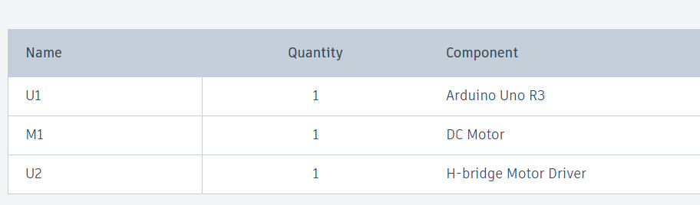
To develop a program that controls a DC motor using an Arduino board. Component:

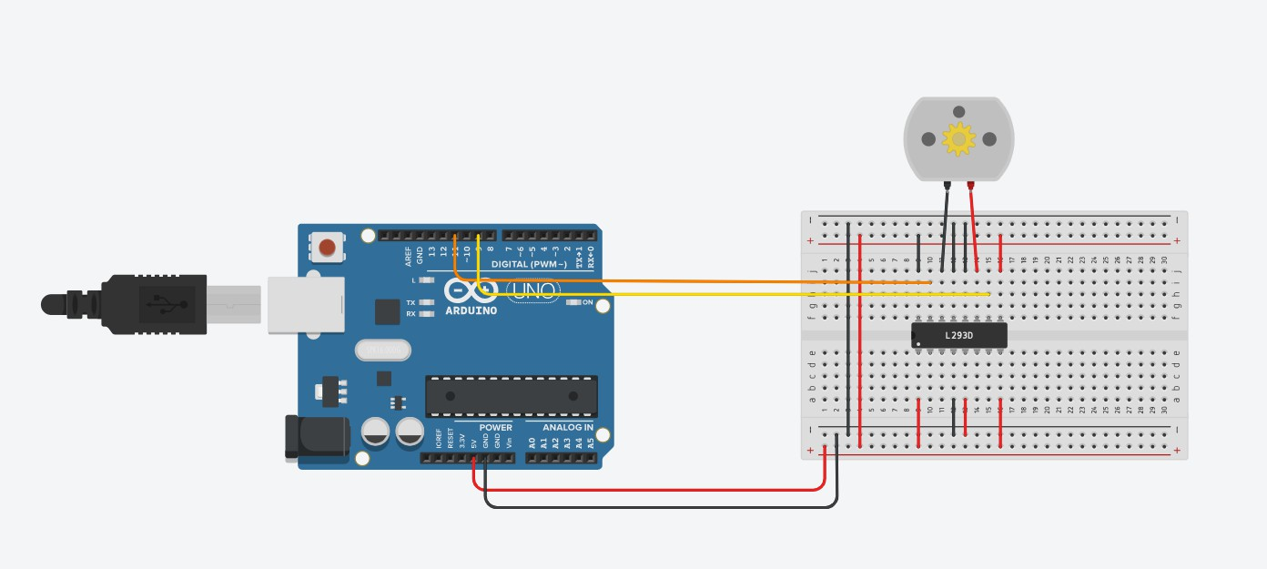
Circuit :

PROCEDURE:
STEP 1: Open Tinkercad
- Go to: https://www.tinkercad.com
- Log in → Click "Circuits" → Click “Create New Circuit”
STEP 2: Add Components
From the components menu, drag and drop:
- Arduino Uno R3
- Breadboard
- DC Motor
- L298N Motor Driver (IC)
- Jumper Wires
STEP 3: Make the Connections
🔌 L298N Motor Driver IC Pin Connections:

L298N Pin | Connects To
Pin 1 (Enable A) | Arduino Digital Pin 9
Pin 2 (Input 1) | Arduino Digital Pin 8
Pin 3 (Output 1) | One terminal of DC Motor
Pin 4 (GND) | GND (to Breadboard/Arduino)
Pin 5 (GND) | GND (to Breadboard/Arduino)
Pin 6 (Output 2) | Other terminal of DC Motor
Pin 7 (Input 2) | Arduino Digital Pin 7
Pin 8 (VCC for Motor) | External 5V (or 9V battery) (optional, or use 5V from Arduino if low-power motor)
Pin 9 (VCC for IC) | 5V from Arduino
Make sure both GNDs of the Arduino and L298N are connected together (common ground).

STEP 4: Upload the Code
Click “Code” → Text Mode → Paste this Arduino code: Program Code:
// C++ code
//
void setup()
{
pinMode(11, OUTPUT); pinMode(9,OUTPUT);
}

void loop()
{
digitalWrite(11, HIGH); digitalWrite(9,LOW);
delay(3000); // Wait for 1000 millisecond(s) digitalWrite(11, LOW); digitalWrite(9,LOW);
delay(3000); digitalWrite(9,HIGH); digitalWrite(11, LOW);
delay(3000); // Wait for 1000 millisecond(s) digitalWrite(11, HIGH); digitalWrite(9,LOW);
delay(3000);
}
STEP 5: Start the Simulation
- Click “Start Simulation”
- The motor should spin forward for 2 seconds, pause, reverse for 2 seconds, then pause again in a loop

Output:

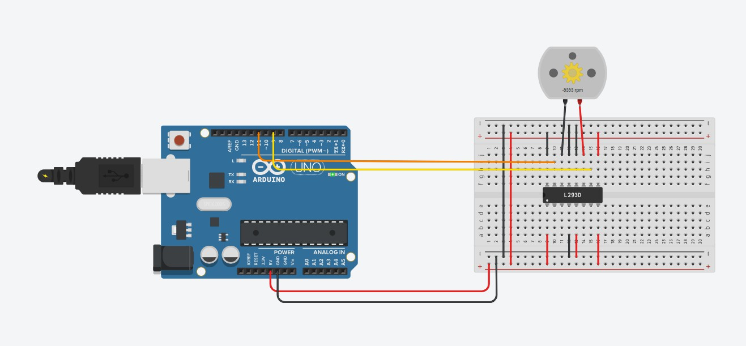

Program 5:
Develop a program to deploy smart street light system using LDR sensor.
AIM
To develop a program to deploy a smart street light system using an LDR (Light Dependent Resistor) sensor with an Arduino board.
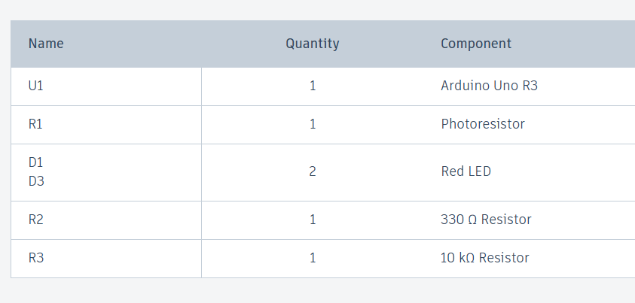
Components:

Circuit:
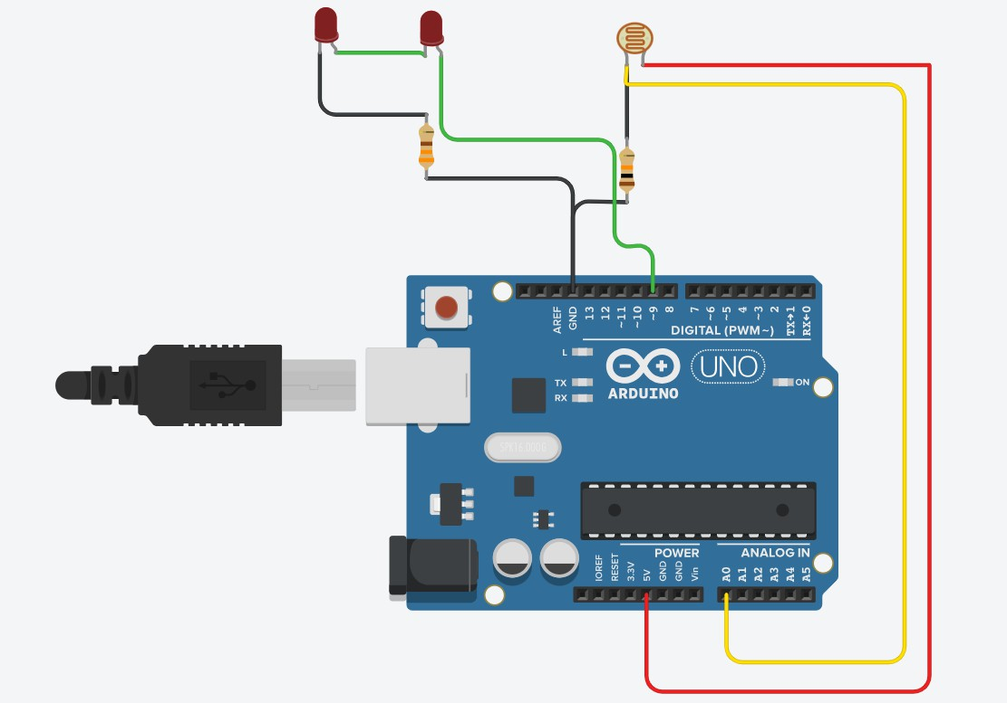

PROCEDURE:
STEP 1: Open Tinkercad
- Go to https://www.tinkercad.com
- Log in → Click “Circuits” → Click “Create New Circuit”

STEP 2: Add Components
Drag and drop the following into the workspace:
  - Arduino Uno R3
  - LDR sensor
  - 2 LEDs
  - Resistors (220Ω and 10kΩ)
  - Jumper wires

STEP 3: Make the Circuit Connections
📷 LDR Circuit (Light Sensor)
  - Connect one leg of the LDR to 5V
  - Connect the other leg of the LDR to:
    - A0 (Analog pin) of Arduino
    - One side of 10kΩ resistor
  - Connect the other side of the 10kΩ resistor to GND
This forms a voltage divider for reading light levels on A0.

- LEDs Circuit
  - Connect anode (long leg) of each LED to Digital Pin 8 and 9
  - Connect cathode (short leg) of each LED to GND through a 220Ω resistor

LED | Anode → | Cathode →
LED1 | Pin 8 | GND via 220Ω

LED | Anode → | Cathode →
LED2 | Pin 9 | GND via 220Ω

STEP 4: Add the Arduino Code
Click on “Code” → Select "Text" mode → Paste this code: Program code:
const int LDR_PIN = A0; const int LED_PIN = 9;
int threshold = 600; // Adjust after Serial Monitor test

void setup() { pinMode(LED_PIN, OUTPUT);
Serial.begin(9600);
}

void loop() {
int ldrValue = analogRead(LDR_PIN); Serial.println(ldrValue); // See values in Serial Monitor

if (ldrValue < threshold) {
digitalWrite(LED_PIN, HIGH); // Turn ON in dark
} else {
digitalWrite(LED_PIN, LOW); // Turn OFF in light
}

delay(500);
}
STEP 5: Start the Simulation
  - Click “Start Simulation”
  - Open the Serial Monitor to view the LDR value
  - Block the LDR (with your cursor or simulate dark conditions)
    - LED1 should turn ON (LED2 OFF) in dark
    - LED2 should turn ON (LED1 OFF) in bright light

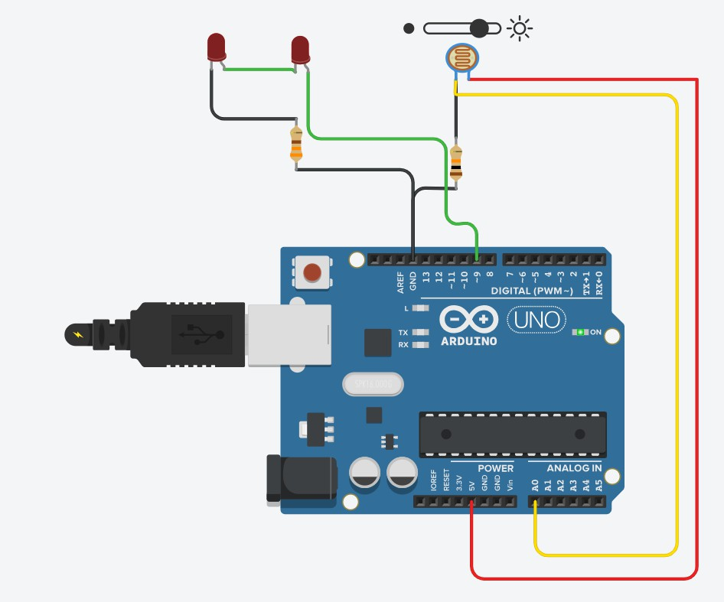
Output:

Program 6:
Develop a program to classify dry and wet waste with the Moisture sensor (DHT22).
AIM:
Develop a program to classify dry and wet waste using a DHT22 sensor based on humidity readings.
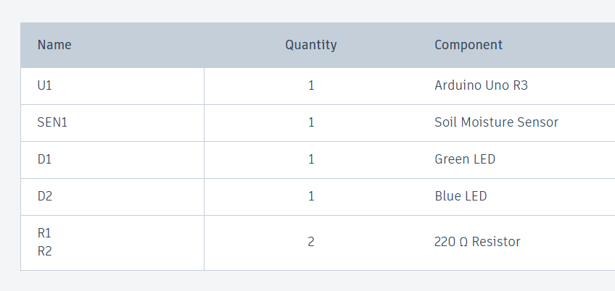
Components:

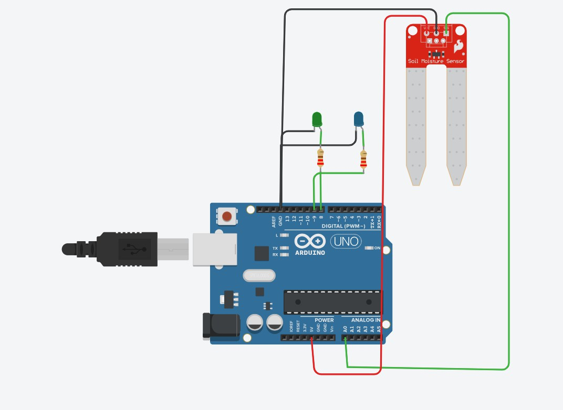
Circuit:

PROCEDURE:
STEP 1: Open Tinkercad
- Go to https://www.tinkercad.com
- Login → Go to "Circuits" → Click “Create New Circuit”

STEP 2: Add Components
Drag the following components into your circuit:
  - Arduino Uno R3
  - Soil Moisture Sensor (with fork and amplifier module)
  - 2 LEDs (Green and Blue)
  - 2 Resistors (220Ω)
  - Jumper wires

STEP 3: Wire the Circuit
🔌 Soil Moisture Sensor Connections:

Soil Sensor Pin | Connects To
VCC | Arduino 5V
GND | Arduino GND
A0 (Analog Out) | Arduino A0

- LED Connections:

LED Color | Anode (Long Leg) → | Cathode →
Green | Digital Pin 8 | GND via 220Ω
Blue | Digital Pin 9 | GND via 220Ω

Use resistors in series with the LEDs to prevent burning them out.

STEP 4: Add the Arduino Code
Click “Code” → Select “Text” mode and paste the following code: Program code:
const int MOISTURE_PIN = A0; // Sensor analog pin const int DRY_LED = 8; // Green LED for dry waste const int WET_LED = 9; // Blue LED for wet waste
int threshold = 600; // Tune this value based on readings void setup() {
Serial.begin(9600);
pinMode(DRY_LED, OUTPUT); pinMode(WET_LED, OUTPUT);
}

void loop() {
int moistureValue = analogRead(MOISTURE_PIN); Serial.print("Moisture: "); Serial.println(moistureValue);

if (moistureValue > threshold) {
// Wet waste
Serial.println("Classified: WET WASTE"); digitalWrite(WET_LED, HIGH); digitalWrite(DRY_LED, LOW);
} else {
// Dry waste
Serial.println("Classified: DRY WASTE"); digitalWrite(DRY_LED, HIGH); digitalWrite(WET_LED, LOW);
}

delay(1000); // Wait for 1 second
}

STEP 5: Start the Simulation
  - Click “Start Simulation”
  - Open the Serial Monitor to view real-time moisture values
  - You can simulate wet/dry conditions by changing the soil sensor’s value in the simulation settings

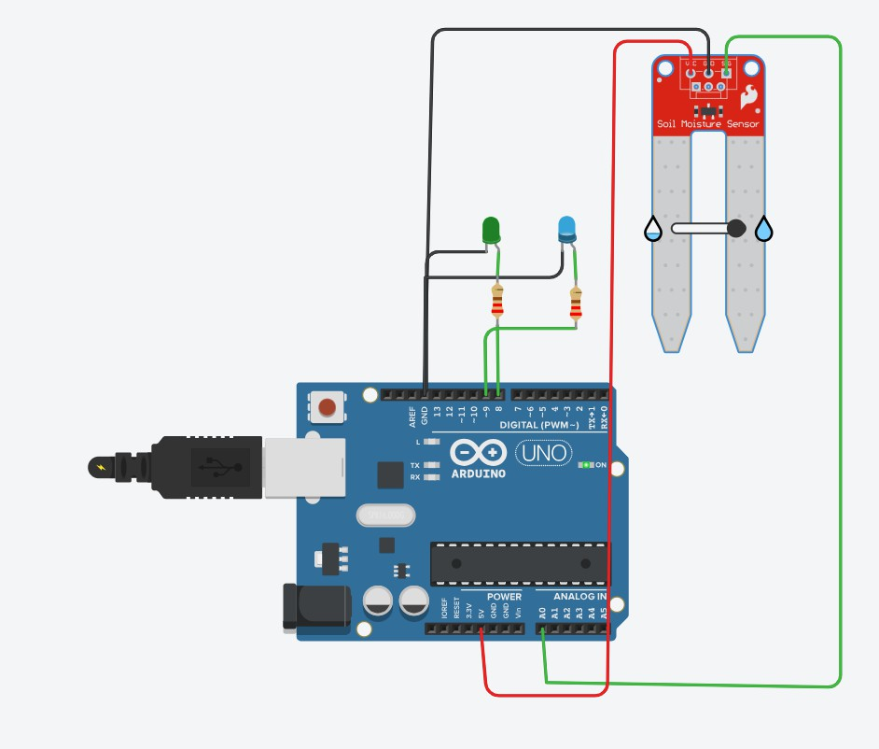
OUTPUT:

Program 7:
Develop a program to read the pH value of a various substances like milk, lime and water.
AIM
To develop a program that reads the pH value of various substances such as milk, lime juice, and water using a pH sensor and Arduino board.
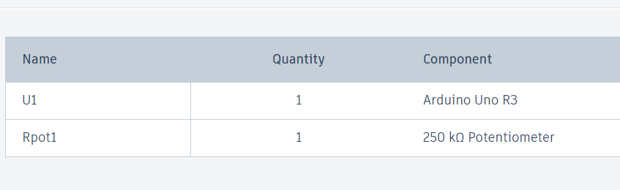
Components:

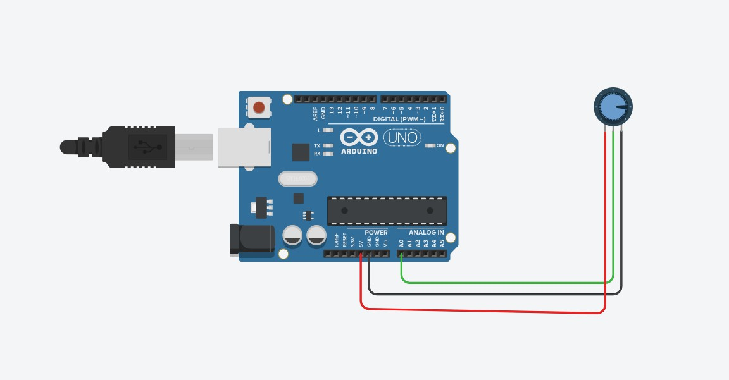
Circuit:

PROCEDURE:
STEP 1: Open Tinkercad
- Visit https://www.tinkercad.com
- Log in → Go to “Circuits” → Click “Create New Circuit”

STEP 2: Add Components
Drag the following components into your workspace:
  - Arduino Uno R3
  - Potentiometer
  - Jumper wires

STEP 3: Wiring the Potentiometer
A potentiometer has 3 pins:
  - Left pin → Connect to GND
  - Right pin → Connect to 5V
  - Middle pin (wiper) → Connect to Analog Pin A0 Wiring summary based on your image:

Potentiometer Pin | Connects To
Left | GND (Black wire)
Right | 5V (Red wire)
Middle (wiper) | A0 (Green wire)

STEP 4: Add the Arduino Code
Click "Code" → Select “Text” Mode → Paste the following code:

Program Code:
const int PH_PIN = A0; // Simulated pH analog input

void setup() { Serial.begin(9600);
}

void loop() {
int analogValue = analogRead(PH_PIN); // Range: 0–1023
float voltage = analogValue * (5.0 / 1023.0); // Convert to voltage (0–5V)

// Simulate pH scale: 0V = pH 0, 5V = pH 14 float pHValue = voltage * (14.0 / 5.0);

Serial.print("Analog: "); Serial.print(analogValue); Serial.print(" | Voltage: "); Serial.print(voltage); Serial.print(" V | pH Value: "); Serial.println(pHValue);

// Classify substance based on pH if (pHValue < 3.0) {
Serial.println("Substance: Lime Juice (Strong Acid)");
} else if (pHValue >= 6.0 && pHValue < 7.0) { Serial.println("Substance: Milk (Weak Acid)");
} else if (pHValue >= 7.0 && pHValue <= 7.5) { Serial.println("Substance: Water (Neutral)");
} else {
Serial.println("Substance: Unknown");
}

delay(1000);
}

STEP 5: Start the Simulation
  - Click “Start Simulation”
  - Open the Serial Monitor (click the monitor icon)
  - Turn the potentiometer knob in the simulation
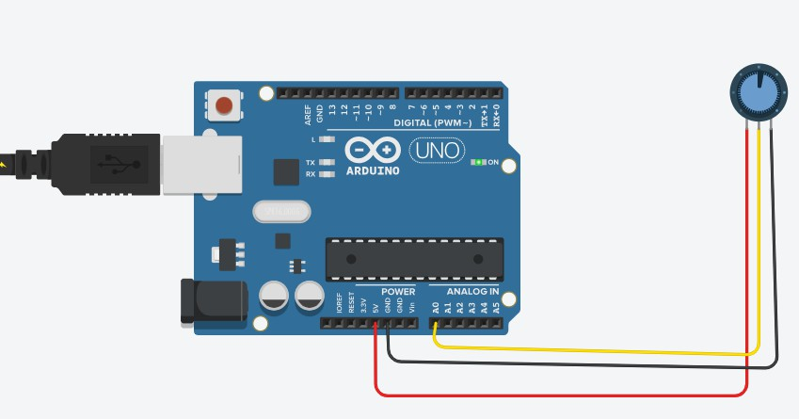
    - You will see values ranging from 0 (min) to 1023 (max) based on the position

    - ​

Output:
Substance: Unknown
Analog: 818 | Voltage: 4.00 V | pH Value: 11.19 Substance: Unknown
Analog: 818 | Voltage: 4.00 V | pH Value: 11.19 Substance: Unknown
Analog: 818 | Voltage: 4.00 V | pH Value: 11.19 Substance: Unknown
Analog: 143 | Voltage: 0.70 V | pH Value: 1.96 Substance: Lime Juice (Strong Acid)
Analog: 143 | Voltage: 0.70 V | pH Value: 1.96 Substance: Lime Juice (Strong Acid)
Analog: 164 | Voltage: 0.80 V | pH Value: 2.24

Substance: Lime Juice (Strong Acid)
Analog: 164 | Voltage: 0.80 V | pH Value: 2.24 Substance: Lime Juice (Strong Acid)
Analog: 164 | Voltage: 0.80 V | pH Value: 2.24 Substance: Lime Juice (Strong Acid)
Analog: 164 | Voltage: 0.80 V | pH Value: 2.24 Substance: Lime Juice (Strong Acid)
Analog: 164 | Voltage: 0.80 V | pH Value: 2.24 Substance: Lime Juice (Strong Acid)
Analog: 164 | Voltage: 0.80 V | pH Value: 2.24 Substance: Lime Juice (Strong Acid)
Program 8:
Develop a program to detect the gas leakage in the surrounding environment.
AIM
To develop a program to detect gas leakage in the surrounding environment using a gas sensor and Arduino.
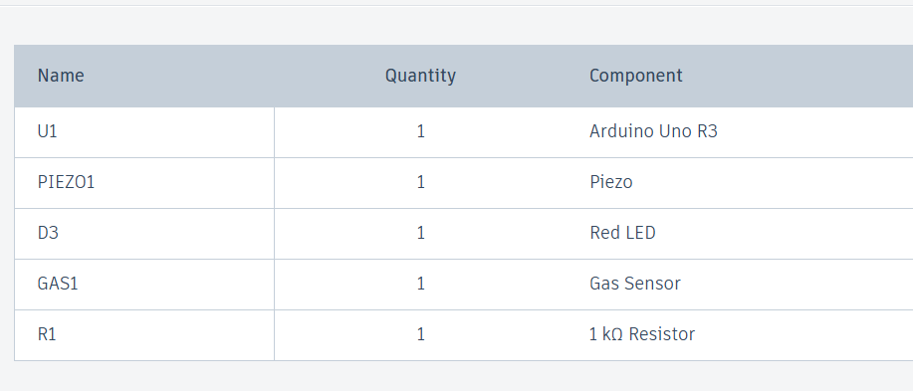
Component:

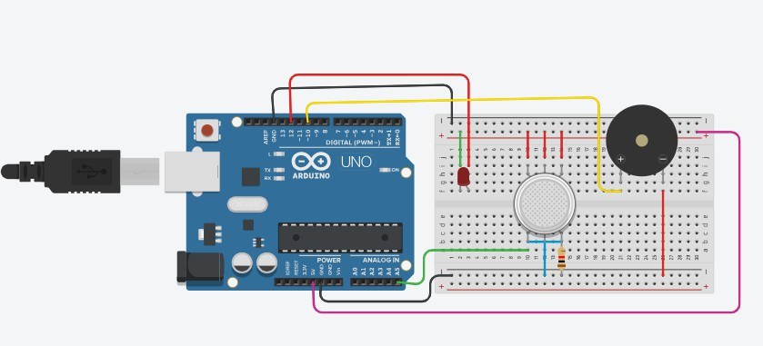
Circuit:

PROCEDURE:
STEP 1: Open Tinkercad
- Go to https://www.tinkercad.com
- Log in → Go to “Circuits” → Click “Create New Circuit”

STEP 2: Add Components
From the components panel, add:
  - Arduino Uno R3
  - MQ-2 Gas Sensor
  - Red LED
  - Buzzer
  - Breadboard
  - Resistors (220Ω, 10kΩ)
  - Jumper wires

STEP 3: Wiring the Components
🔌 MQ-2 Gas Sensor Connections (Analog Output)

MQ-2 Pin | Connects To
VCC | Arduino 5V

MQ-2 Pin | Connects To
GND | Arduino GND
A0 | Arduino A0

Some versions may also have a DO (digital out) — use A0 for analog input.

- LED Connection

LED Leg | Connects To
Anode (+) | Arduino Pin 8 (via 220Ω resistor)
Cathode (–) | GND

🔊 Buzzer Connection

Buzzer Pin | Connects To
+ (long pin) | Arduino Pin 9
– (short pin) | GND

STEP 4: Add the Arduino Code
Click “Code” → Select “Text” mode → Paste this code: Program code:
int redLed=12; int buzzer=10;
int smokeA0=A5;
int sensorThree=100; void setup()
{
pinMode(redLed,OUTPUT); pinMode(buzzer,OUTPUT); pinMode(smokeA0,INPUT); Serial.begin(9600);
}
void loop()

{
int analogSensor=analogRead(smokeA0); Serial.print("Pin A0:"); Serial.println(analogSensor); if(analogSensor>sensorThree)
{
digitalWrite(redLed,HIGH); tone(buzzer,1000,200);
}
else
{
digitalWrite(redLed,LOW); noTone(buzzer);
}
delay(100);
}
STEP 5: Start the Simulation
  - Click “Start Simulation”
  - Open the Serial Monitor
  - Increase the analog value of the MQ sensor in the simulation settings to simulate gas detection
    - Once it goes above 400, the LED and buzzer turn ON
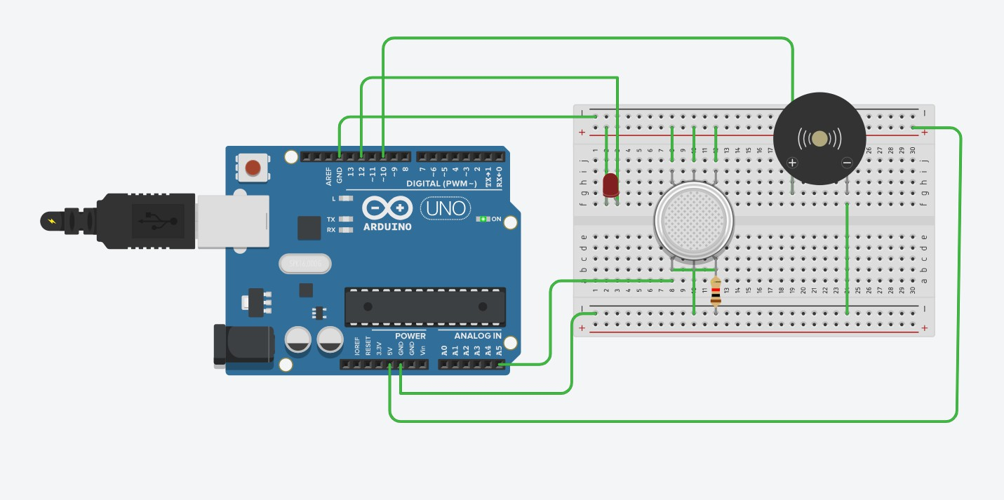
Output:

Pin A0:122 Pin A0:122 Pin A0:122 Pin A0:130 Pin A0:146 Pin A0:85 Pin A0:85 Pin A0:85 Pin A0:85 Pin A0:85 Pin A0:85 Pin A0:85 Pin A0:85 Pin A0:85 Pin A0:85 Pin A0:85 Pin A0:85 Pin A0:85 Pin A0:85 Pin A0:85 Pin A0:85 Pin A0:85 Pin A0:85 Pin A0:85 Pin A0:85 Pin A0:85 Pin A0:85 Pin A0:85 Pin A0:90 Pin A0:121 Pin A0:154 Pin A0:150 Pin A0:149 Pin A0:149 Pin A0:181 Pin A0:251 Pin A0:243 Pin A0:277 Pin A0:224 Pin A0:136

Pin A0:124 Pin A0:119 Pin A0:114 Pin A0:123 Pin A0:142 Pin A0:130 Pin A0:100 Pin A0:90 Pin A0:85 Pin A0:85 Pin A0:85 Pin A0:85 Pin A0:85 Pin A0:85 Pin A0:85 Pin A0:85 Pin A0:85 Pin A0:85 Pin A0:85 Pin A0:87 Pin A0:133 Pin A0:142 Pin A0:142 Pin A0:147 Pin A0:149 Pin A0:150

Program 9:
Develop a program to demonstrate weather station readings using Arduino.
AIM
To develop a program to demonstrate a weather station using Arduino to measure temperature, humidity, and optionally atmospheric pressure.
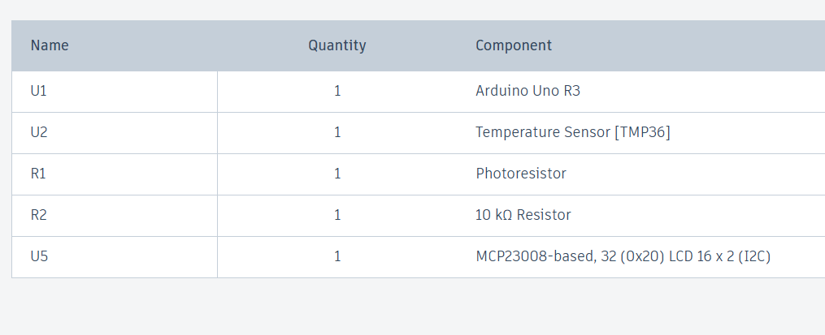
Components:
Circuit:
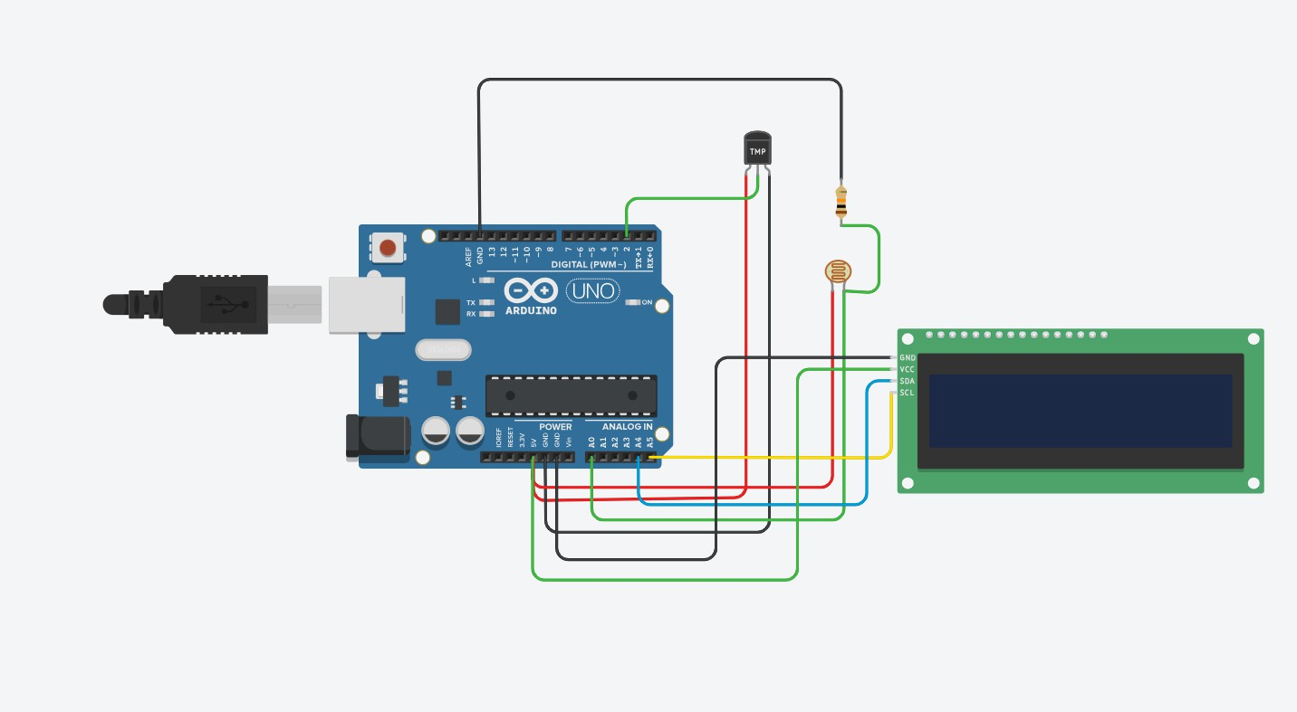

PROCEDURE:
STEP 1: Open Tinkercad
- Go to https://www.tinkercad.com
- Log in → Go to “Circuits” → Click “Create New Circuit”

STEP 2: Add Components
Search and drag the following into your workspace:
  - Arduino Uno R3
  - LM35 Temperature Sensor
  - 16x2 LCD Display (standard)
  - 10kΩ potentiometer
  - Breadboard
  - Jumper wires

STEP 3: Wire the Circuit
🔌 LM35 Temperature Sensor Wiring

LM35 Pin | Connects To
Left (VCC) | Arduino 5V
Middle (Vout) | Arduino A0
Right (GND) | Arduino GND

- LCD to Arduino Wiring (in 4-bit mode)

LCD Pin | Connects To
VSS | GND
VDD | 5V

LCD Pin | Connects To
VO | Middle pin of potentiometer (for contrast)
RS | Pin 12
RW | GND
E | Pin 11
D4 | Pin 5
D5 | Pin 4
D6 | Pin 3
D7 | Pin 2
A (LED+) | 5V (optional for backlight)
K (LED-) | GND
🔁 Potentiometer Connections
  - One side → GND
  - Other side → 5V
  - Middle → LCD VO pin (for contrast)

STEP 4: Add the Arduino Code
Click “Code” → Select “Text” mode → Paste the following code:

Program code:
#include <LiquidCrystal.h>

// LCD pin setup: RS, E, D4, D5, D6, D7 LiquidCrystal lcd(7, 6, 5, 4, 3, 8);

// TMP36 on A1, LDR on A0 const int tempPin = A1; const int ldrPin = A0;

void setup() { Serial.begin(9600); lcd.begin(16, 2); lcd.print("Weather Station"); delay(2000);
lcd.clear();
}

void loop() {
// Read temperature from TMP36
int tempReading = analogRead(tempPin); float voltage = tempReading * (5.0 / 1023.0); float temperatureC = (voltage - 0.5) * 100;

// Read LDR and map to light percentage int ldrValue = analogRead(ldrPin);
int lightPercent = map(ldrValue, 0, 1023, 100, 0); // 0 = bright, 100 = dark

// Print to Serial Monitor Serial.print("Temp: "); Serial.print(temperatureC); Serial.print(" °C, Light: "); Serial.print(lightPercent); Serial.println("%");

// Display on LCD

lcd.setCursor(0, 0); lcd.print("Temp:"); lcd.print(temperatureC, 1); lcd.print((char)223); // Degree symbol lcd.print("C ");

lcd.setCursor(0, 1); lcd.print("Light:"); lcd.print(lightPercent); lcd.print("% ");

delay(2000);
}
STEP 5: Start the Simulation
  - Click “Start Simulation”
  - You should see temperature values displayed on the LCD screen
  - You can simulate different temperatures by adjusting the LM35 in the Tinkercad panel
Output:
Temp: -33.87 Â°C, Light: 95%
Temp: 291.15 Â°C, Light: 95%
Temp: 262.81 Â°C, Light: 95%
Temp: 232.50 Â°C, Light: 95%
Temp: 310.70 Â°C, Light: 95%
Temp: 209.53 Â°C, Light: 95%

Program 10:
Develop a program to setup a UART protocol and pass a string through the protocol.
AIM
To develop a program that sets up UART communication and transmits a string using the UART protocol.
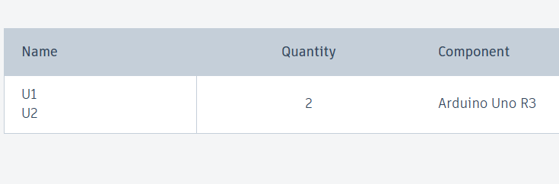
Components:
Circuit:
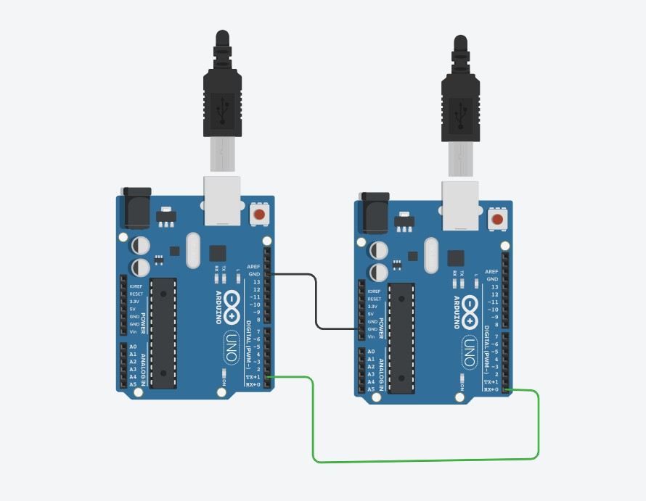

PROCEDURE:
STEP 1: Open Tinkercad
- Go to https://www.tinkercad.com
- Log in → Go to Circuits → Click Create New Circuit

STEP 2: Add Components
  - Drag 2 Arduino Uno boards into the workspace.

STEP 3: Connect the Arduinos

Connection | Arduino 1 Pin | Arduino 2 Pin
Ground (GND) | GND | GND
TX → RX | Pin 1 (TX) | Pin 0 (RX)
RX → TX | Pin 0 (RX) | Pin 1 (TX)

In your image, only one data wire and GND wire are connected; typically, TX of Arduino1 goes to RX of Arduino2 and vice versa for full duplex.

STEP 4: Upload Arduino Sketches
Program code:
Arduino 1 (Sender):

void setup() { Serial.begin(9600);
}

void loop() {
Serial.println("Hello from Arduino 1"); delay(1000);
}
Arduino 2 (Receiver):
Code for Receiver (Arduino 2):

void setup() { Serial.begin(9600);
}

void loop() {
if (Serial.available()) {
String msg = Serial.readStringUntil('\n'); Serial.print("Received: "); Serial.println(msg);
}
}
STEP 5: Simulate
  - Upload sketches to respective Arduinos (one sender, one receiver).
  - Start simulation.
  - Open Serial Monitor for Arduino 2 to see incoming messages.
Output:
Sender (Arduino 1):
Hello from Arduino 1 Hello from Arduino 1 Receiver (Arduino 2):
Received: Hello from Arduino 1 Received: Hello from Arduino 1

Program 11:
Develop a water level depth detection system using Ultrasonic sensor.
AIM
To develop a system to detect water level depth using an ultrasonic sensor and Arduino.
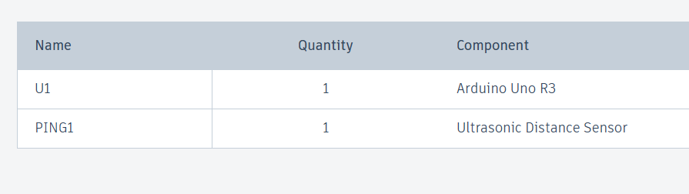
Components:
Circuit:
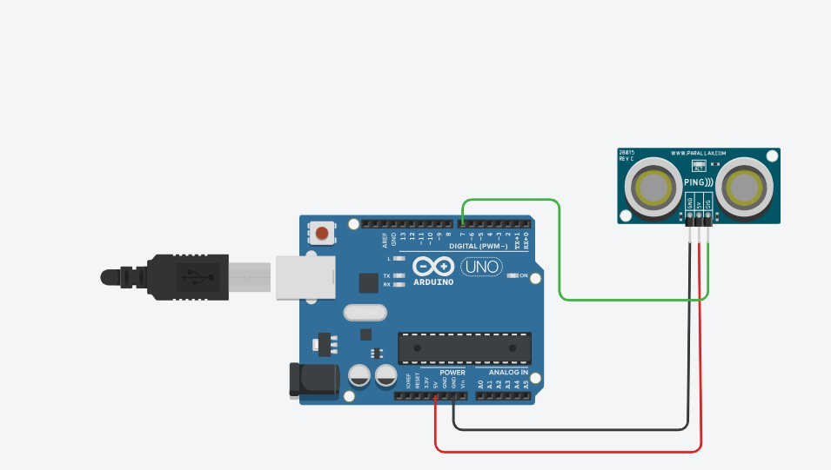

PROCEDURE:
STEP 1: Open Tinkercad
- Go to https://www.tinkercad.com
- Log in → Go to Circuits → Click Create New Circuit

STEP 2: Add Components
  - Drag Arduino Uno and HC-SR04 Ultrasonic Sensor into the workspace.

STEP 3: Wiring the HC-SR04

HC-SR04 Pin | Connects To Arduino Pin
VCC | 5V
GND | GND
Trig | Digital Pin 7
Echo | Digital Pin 6

STEP 4: Add Arduino Code
Click “Code” → Select “Text” mode → Paste this code: Program Code:
const int sensorPin = 7; // SIG pin

long duration; float distanceCM;

void setup() { Serial.begin(9600); pinMode(sensorPin, OUTPUT);
}

void loop() {

// Send trigger pulse pinMode(sensorPin, OUTPUT); digitalWrite(sensorPin, LOW); delayMicroseconds(2); digitalWrite(sensorPin, HIGH); delayMicroseconds(10); digitalWrite(sensorPin, LOW);

// Change pin to input to read echo pinMode(sensorPin, INPUT);

// Read the echo pulse duration duration = pulseIn(sensorPin, HIGH);

// Calculate distance in cm distanceCM = duration * 0.034 / 2;

Serial.print("Distance: "); Serial.print(distanceCM); Serial.println(" cm");

delay(1000);
}
STEP 5: Start Simulation
  - Click “Start Simulation”
  - Open the Serial Monitor to see distance readings update continuously
  - You can manually move the sensor or objects in Tinkercad to see changes in distance values.

Output:

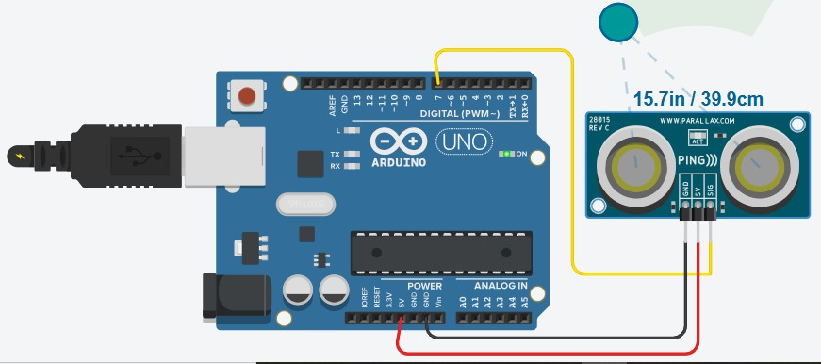
Distance: 332.03 cm
Distance: 332.04 cm
Distance: 332.04 cm
Distance: 332.06 cm
Distance: 332.04 cm
Distance: 332.04 cm
Distance: 332.04 cm
Distance: 161.04 cmDistance: 161.02 cm
Distance: 332.08 cm
Distance: 332.08 cm

Program12:
Develop a program to simulate interfacing with the keypad module to record the keystrokes.
AIM
To develop a program to simulate interfacing with a keypad module and record the keystrokes using an Arduino.
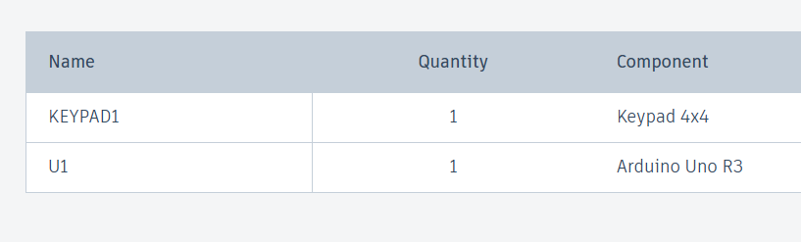
Components:
Circuit:
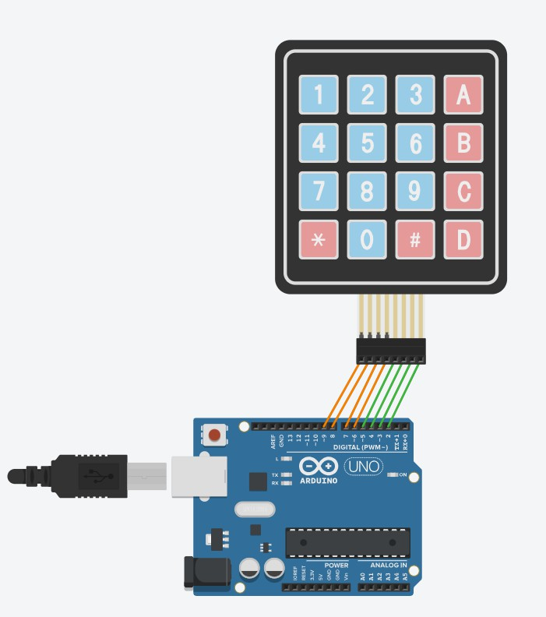

PROCEDURE:
STEP 1: Open Tinkercad
- Go to https://www.tinkercad.com
- Log in → Go to Circuits → Click Create New Circuit

STEP 2: Add Components
  - Drag Arduino Uno
  - Drag 4x4 Matrix Keypad

STEP 3: Wiring the Keypad

Keypad Pin | Arduino Pin
1 (Row 1) | 9
2 (Row 2) | 8
3 (Row 3) | 7
4 (Row 4) | 6
5 (Col 1) | 5
6 (Col 2) | 4
7 (Col 3) | 3
8 (Col 4) | 2

STEP 4: Add the Arduino Code
Click “Code” → Select “Text” mode → Paste the following code: Program Code:
#include <Keypad.h>

const byte ROWS = 4; // Four rows const byte COLS = 4; // Four columns

char keys[ROWS][COLS] = {
{'1','2','3','A'},
{'4','5','6','B'},
{'7','8','9','C'},
{'*','0','#','D'}
};

byte rowPins[ROWS] = {9, 8, 7, 6}; // Connect to the row pinouts of the keypad byte colPins[COLS] = {5, 4, 3, 2}; // Connect to the column pinouts

Keypad keypad = Keypad(makeKeymap(keys), rowPins, colPins, ROWS, COLS);

String inputBuffer = "";

void setup(){ Serial.begin(9600);
Serial.println("Keypad Ready. Press any key...");
}

void loop(){
char key = keypad.getKey(); if (key){
inputBuffer += key; Serial.print("Key Pressed: "); Serial.println(key); Serial.print("Current Input: "); Serial.println(inputBuffer);
}
}
STEP 5: Start Simulation
  - Click “Start Simulation”
  - Open the Serial Monitor
  - Press buttons on the virtual keypad and watch the pressed keys appear on the Serial Monitor.

Output:
Keypad Ready. Press any key... Key Pressed: 1
Current Input: 1 Key Pressed: A Current Input: 1A Key Pressed: 5 Current Input: 1A5 Key Pressed: # Current Input: 1A5# Key Pressed: D
Current Input: 1A5#D Key Pressed: *
Current Input: 1A5#D*

